ARTIST UNKNOWN
Tribal sculpture from Papua New Guinea

AFRICAN MASK
Ivory Coast artefact, mask

PAPUA NEW GUINEA FIGURE
Sepik River, artefact
AFRICAN MASK
Benin, mask

FIGURE
Papua New Guinea, artefact

ARTIST UNKNOWN
Palm Beach undated
oil on cardboard

IAN ABDULLAH
Camping along the River Cobdola 1998
mixed media on paper

ENGLAND BANGALA
Jin Jarbul (Rainbow serpent) 1998
watercolour on paper

JOHN BELLAMY
Untitled undated
etching

THELMA BURKE
The morning star undated
acrylic on linen

KEVIN CONNOR
Iron Bridge (to Pier 19, Pyrmont) III undated
gouache and ink on paper

KEVIN CONNOR
Iron Bridge (to Pier 19, Pyrmont) I undated
gouache and ink on paper

ELISABETH CUMMINGS
Still life with pears undated
oil on board

KITTY KANTILA
Clan group: Fire, Dance: Rain 1998
ochres on paper

MARTIN KING
Melancholia II 2013
etching

LEON KOSSOFF
Untitled undated
charcoal on paper

ROSS LAURIE
Untitled (landscape) undated
oil on canvas

FERNANDO LEGER
‘L’eau’, Verve 1937
lithograph

KEVIN LINCOLN
Untitled (Seashell still life) 1985
gouache on paper

EUAN MACLEOD
Moored, Paradise Harbour 2009
oil on paper

HENRI MATISSE
Femme au Chapeau 1935
lithograph

WILLIAM ROBINSON
Late sunlight and afternoon cloud 1993
lithograph

GEORGES ROUAULT
Pierrot 1939
lithograph, published by Tériade for Verve

PETER SHARP
Untitled undated
oil stick on canvas

ANTONI TAPIES
Untitled undated
charcoal and wash on paper

TONY TUCKSON
Untitled 1968-73
charcoal on paper

JOHN TURIER
Untitled (musical instrument sculpture)
undated
mixed media

KEN WHISSON
Perugia 1978
ink on paper

THANK YOU

The S.H. Ervin Gallery is enormously grateful to Tom Carment & Jan Idle, Nicholas Harding & Lynne Watkins, Guy Maestri and Idris & Glennis Murphy for sharing their collections in the exhibition.

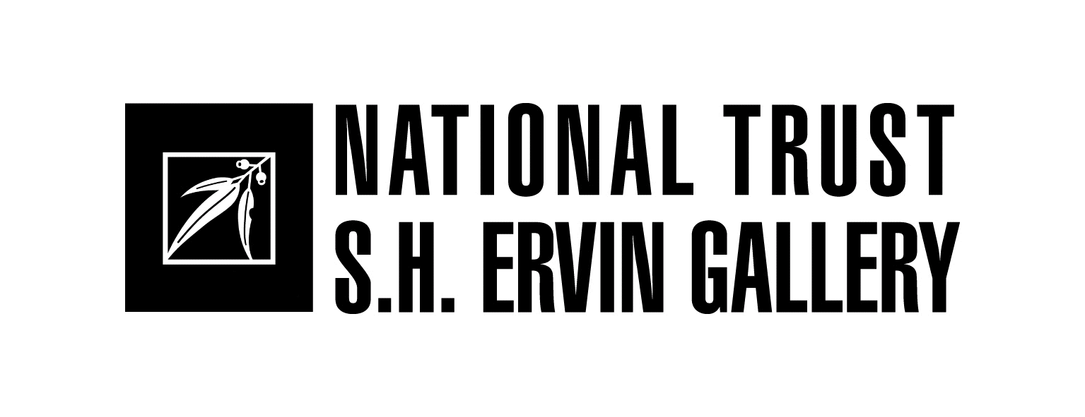
(more) PRIVATE LIVES
The artist as collector
27 February – 10 April 2016

TOM CARMENT COLLECTION

ARTIST UNKNOWN
Japanese fan print printed 1985
colour woodblock print

ROBERT BRAIN
Kabuki actor with gun 1984
tapestry

ROBERT BRAIN
Kabuki actor, boxing 1985
tapestry

RICHARD BLACK
Animal kingdom, the first cloud and side of beef (Rembrandt) 2013
collage

SAM BYRNE
Sturt peas 1963
oil and enamel on masonite

SIMON BLAU
Toilet 1996
oil on paper on canvas

KATRINA COLLINS
White bucket 2002
acrylic on board

KATRINA COLLINS
Beach flowers 2005
oil on wood panel

JOSEPH CONROY
Cumulonimbus 2010
oil on board

OLIVE COTTON
The sunlit tree 1992-94
silver gelatin print

ELISABETH CUMMINGS
Still life 2000
oil on board

ROX DE LUCA
Saved (pink #1) 2012
found plastic and wire

ARNULF EBATARINJA
Western McDonnell Ranges 1960s
watercolour on paper on cardboard

MICHELE ELLIOT
Untitled 2009
pencil on paper

NEIL EVANS
Tartan trolley 2010
acrylic on card bus ticket

STUART FLEMING
SRG 2008
ink on board

JAN IDLE
Seven years sitting on a rock (Japanese proverb) 1996
embroidery on silk

JAN IDLE
Family wagon 1996
embroidery on silk

HEIDI JACKSON
Muramarang Gums, late afternoon 2015
acrylic on paper

ILDIKO KOVACS
Untitled 1994
mixed media

SALLY McINERNEY
Strangers in town - Koorawatha dog show 1965
silver gelatin print

EUAN MACLEOD
See saw 2 in a boat 2006
oil on canvas

PENELOPE METCALF
Block still life 2013
acrylic on board

FRANK NOWLAN
South Coast surf club 2003
acrylic on canvas

Edwin Pareroultja
Western McDonnell Ranges 1950s
watercolour on paper

IVY PAREROULTJA
Western McDonnell Ranges 2014
watercolour on paper on cardboard

SASSY PARK
Greetings from Port Pirie 2011
watercolour on paper

JOAN ROSS
Bird 2008
kangaroo skin

KARL SCHWERDTFEGER
Dog skulls 2009
silver gelatin print

OTTO SCHWERDTFEGER
Untitled, (Life of bionicles series) 2010
gicleé print

JUDE SIMES
Untitled 2011
acrylic on bent plywood

JUDE SIMES
Untitled 2010
gouache on paper

TANYA SPARKE
White - browed babbler 2008
mixed media collage

LI WENMIN
Encounter - the taste of rain 2015
collage, ink, and wash on paper

NICHOLAS HARDING COLLECTION

FRANK AUERBACH
Tretire 1 1975
screenprint and intaglio

LIONEL BAWDEN
Untitled undated
pencils, mixed media

PADDY BEDFORD
Red pocket 2002
ochres on linen

KRISTA BERGA
Warsaw series undated
bronze

PETER BOOTH
Figures in the snow 1992-93
charcoal and casein on joined paper

CRESSIDA CAMPBELL
Railway tracks, Melbourne 1995
coloured woodblock print

LUCY CULLITON
Koala undated
oil on board

RACHEL ELLIS
Kitchen interior 1996
charcoal on paper

LUCIEN FREUD
Girl sitting 1987
etching
ALBERT GIACOMETTI
Untitled undated
etching

FRANCISCO DE GOYA
Done Hay Ganas Hay Maña - Where there’s a will there’s a way 1864
etching , plate 13 from Los Proverbios

FRANCISCO DE GOYA
Lluvia de toros - Rain of bulls 1877
etching, plate from Los Proverbios

MICHELLE HISCOCK
Memory of the Loire 2000
oil on gessoed paper

ALAN JONES
Darren undated
colour photograph

LEON KOSSOFF
From Degas: Combing hair (La Coiffure) 1988
drypoint etching

AMANDA MARBERG
Frontier Marshall 2006
oil on linen

MIKE PARR
Untitled (portrait 4) 1989
etching

PABLO PICASSO
Untitled (two female nudes) undated
etching
ANDREW QUILTY
Untitled undated
colour photograph

BEN QUILTY
Gummy Torana 2004
oil on canvas

WILLIAM ROBINSON
To Egg Rock, Numinbah 1998
ink on paper

EVAN SALMON
Sledge 1992
oil on linen

LUKE SCIBERRAS
Managers quarters, Wilcannia undated
oil on board

SEAN SCULLY
Day 2005
etching

TIM SILVER
Untitled (Killing me softly) version 4 2004 - 05
archival ink on paper

ANN THOMSON
Untitled 2009
oil on paper
FRED WILLIAMS
Landscape and green owl 1965-66
etching and aquatint

JOHN WITZIG
Nigel in Western Australia c. 1970
silver gelatin print

GUY MAESTRI collection

GILES ALEXANDER
San Agnese in Agone 2008
oil on polyester

BILLY BENN
Untitled (landscape) undated
acrylic on plywood

BILLY BENN
Untitled (landscape) undated
acrylic on canvas

ADAM CULLEN
What happens when you die in afterlife
2005 acrylic on canvas

FRANCISCO GOYA
Los Desastres de la Guerra, 1808 - 1812, The Disasters of War, Lo poor es pedir (The worst is to beg) 1863
etching

PHILIP HANNAFORD
Olympic partner undated
oil on board

STEVEN HARVEY
Promised, Ubir Rock, Kakadu 2009
Indian powdered pigments on sheets of paper

CHRIS HORDER
Tea time 2006
oil on canvas

ALAN JONES
That’s the way it is #6 2009
oil on linen

TIM KYLE
Untitled undated
painted plaster

EUAN MACLEOD
Russell’s Top 2014
oil on canvas

ANTHONY MAESTRI
Untitled (landscape) undated
acrylic on canvas

GUY MAESTRI
Wreck #13 2015
oil on canvas

TESS NAPALJARRI ROSS
Warlu Kurlang undated
oil on canvas

JOHN OLSEN
Drawing still-life withstudents 2007
ink and crayon on paper

BEN QUILTY
Untitled
oil on canvas

BEN QUILTY
Guido 2013
colour pencil and wash on paper

BEN QUILTY
Captain Sullivan, Al Minhad Airbase 2011
pen and wash on paper

LUKE SCIBERRAS
Study for McCulloch’s Range 2014
oil on board

LUKE SCIBERRAS
Jerry Jangle’s land, Lajamanu 2012
gouache on paper

RANDALL SINNAMON
Untitled undated
carved drift wood

DENISE SYMONDS
Untitled (after Guy Maestri Ball’s Pyramid 2013) undated
embroidery

AIDA TOMESCU
Untitled 1999
acrylic on paper

IDRIS MURPHY COLLECTION

ARTIST UNKNOWN
Steel shield undated Papua New Guinea
steel drum

ARTIST UNKNOWN
Sculpture from New Ireland

ARTIST UNKNOWN
African mask on a stand
acquired in Paris

