Banksias Balls Head, Sydney 1992 woodblock print 60 x 60cm Private Collection

Gore Bay, Sydney 1992 woodblock 60 x 88cm Private Collection

Bungan Beach 1993 woodblock 88 x 88cm Private Collection

Lilies with Indian Cloth 1994 woodblock print 81.5 x 48cm Private Collection

From the balcony 1991 woodblock 120 x 90cm Private Collection

Interior with Kilim 1995 woodblock 48 x 89cm Private Collection

Sydney Harbour triptych 1998 woodblock 50 x 122cm, three panels Private Collection

Burley Griffin house, Avalon 1999 woodblock print 67 x 119cm Private Collection, courtesy Olsen Irwin Gallery, Sydney
Peeling bark 1999 woodblock Private Collection

The path 1989 woodblock Private Collection

White waratah 2000 carved woodblock, hand-painted in watercolour pigment Art Gallery of New South Wales, Margaret Hannah Olley Art Trust 2002

Banksias 2002 woodblock 91 x 60cm Private Collection

Interior with black lacquer chair 2007 woodblock 117 x 89cm Private Collection
Pink gum blossom watercolour on plywood 2009 Private Collection, courtesy Sophie Gannon Gallery, Melbourne

Interior with cat 2010 woodblock 92 x 50cm Private Collection
Flannel flowers with clouds 2013 woodblock Private Collection
Shell collection 2010 woodblock print Private Collection
Trees and water 2001 woodblock Private Collection
Eucalypts 1999 woodblock print Private Collection

Shelf still life 2012 woodblock Private Collection, courtesy 69 John St. Gallery Sydney

Flannel flowers 2013 woodblock print 98.7 x 155.8 cm courtesy of Rob and Jenny Ferguson

Hoya in decanter 2013 unique woodblock print 150.2 x 37.2 cm Private Collection, courtesy Philip Bacon Galleries
Black bamboo 2014 woodblock print 40.2 x 51cm Private Collection
THANK YOU
We would like to thank each of the living artists represented in the exhibition: Cressida Campbell (S.H. Ervin Gallery) Elisabeth Cummings (Manly Art Gallery & Museum) and John Olsen, Kevin Connor & Peter Kingston (Mosman Art Gallery) for the enthusiasm with which they have embraced the project. We would equally like to thank the curator Lou Klepac OAM who has worked tirelessly to bring the project to fruition.
In addition we are grateful for the support of the Gordon Darling Foundation who have assisted with the production of the catalogue and Beyond the Wharf & Grays Online for their in kind support. Special thanks to the extended family of Grace Cossington Smith for their support. The exhibition would not be possible without the many substantial loans from private collections and public institutions whose support has been crucial to the process including the Art Gallery of New South Wales, National Gallery of Australia, National Gallery of Victoria, Art Gallery of South Australia, Newcastle Art Gallery, UNSW Art Collection, University of Sydney, Mosman Art Gallery.
We wish to thank the Directors and staff of the following organisations who assisted greatly with facilitating several loans including Olsen Irwin Gallery, Sydney, Philip Bacon Galleries, Brisbane, Sophie Gannon Gallery, Melbourne & 69 John Street, Sydney.
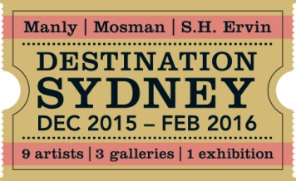
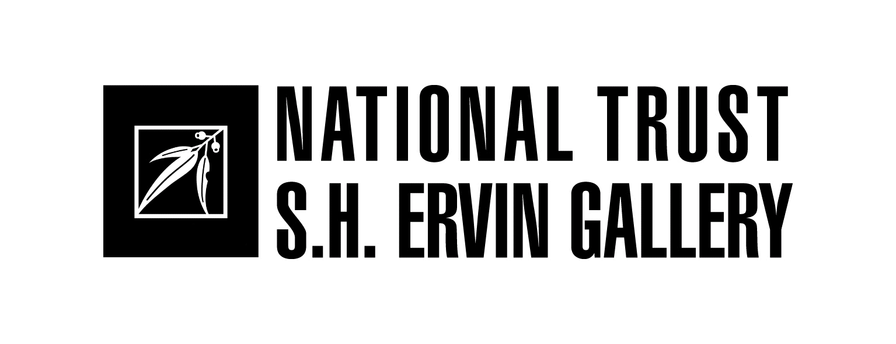
DESTINATION SYDNEY
11 December 2015 – 21 February 2016

Destination Sydney is the result of the collaborative efforts of three of Sydney’s leading public art galleries – Manly Art Gallery and Museum (est. 1930), Mosman Art Gallery (est. 1998) and the S.H. Ervin Gallery (est. 1978) – to work together, along with luminary curator Lou Klepac, to create an exhibition on a scale that they otherwise could not achieve individually. The triangular connection of the three galleries, linked by the magical waters of Sydney harbour, encourages visitors to explore and experience each venue over the summer.

The genesis of the exhibition came from the inspiration that so many artists have drawn from Sydney. It presents a unique perspective on the exchange of selected twentieth century artists from inside and outside Sydney, from its unrivalled landscape and how their contributions have become synonymous with the visual culture of Sydney.

As the concept progressed, it became apparent that to respond to the brief in any meaningful way, the representation in depth of key artists was preferable to simply displaying one work from each possible artist. The artists selected were based on holdings in the collections of the three galleries, on their exhibition histories and following extensive discussion amongst the curatorium members.

Manly’s picturesque site makes it fitting for the iconic views by Brett Whiteley, the serenity and dream-like renderings by Lloyd Rees and the intuitive and painterly landscapes and interiors of Elisabeth Cummings. Mosman’s selection of John Olsen, Kevin Connor and Peter Kingston reflect those artists’ interests in the activities of Sydney and its harbour. Both Connor and Kingston have extended histories of working and residing in Mosman and neighbouring North Sydney, while Olsen's recent gift of The rolling sea (2015), a painting which references Arthur Streeton’s Sydney Harbour (1895), reflects his close relationship with the gallery.

S.H. Ervin Gallery’s commanding position atop Observatory Hill, alongside the Harbour Bridge, made the inclusion of Grace Cossington Smith a must. One cannot think of the amazing Harbour Bridge that dominates the city, without thinking of one of the greatest paintings of this subject by the quiet and modest artist, Grace Cossington Smith, who produced a pictorial structure in oil almost as impressive as the one in iron and steel. Along with Margaret Preston, a masterful image maker and modernist icon and contemporary artist Cressida Campbell, whose technical virtuosity & sublime subject matter feature in her works, this selection continues the S.H. Ervin Gallery’s commitment in promoting the work of Australian women artists.

This exhibition is the start of future collaboration between the three galleries to bring major exhibitions and events to the people of Sydney. We hope you enjoy our city through the eyes and personal experiences of these nine magnificent artists.

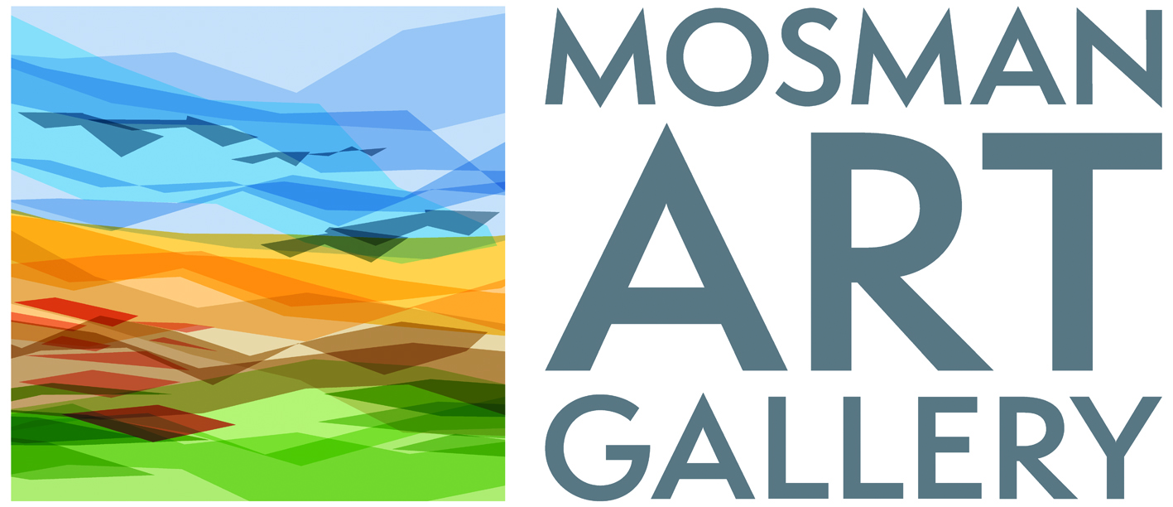
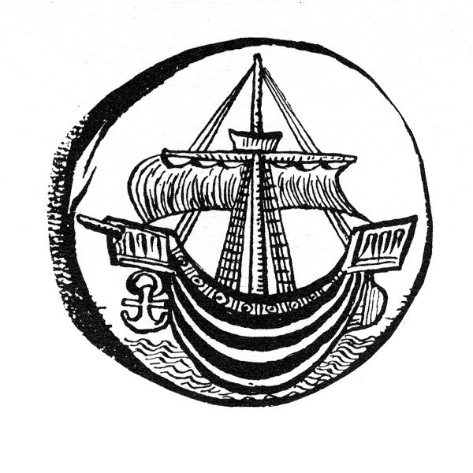
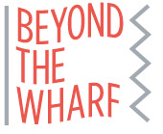
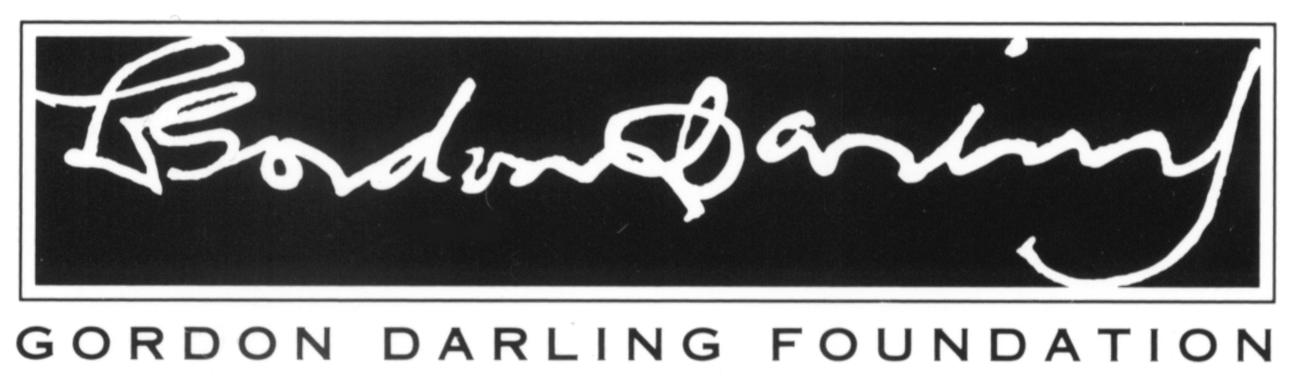

MARGARET PRESTON (1875-1963)

Frenchman’s beach, Neutral Bay c.1920 woodcut print 21x 26.3cm National Gallery of Australia

Shell Cove, Sydney 1920 woodblock print 21.6 x 27.1cm National Gallery of Australia
Circular Quay 1920 woodblock print 21.5 x 27.4cm National Gallery of Australia

Thea Proctor’s tea party 1924 oil on canvas on hardboard Art Gallery of New South Wales

Flapper c.1925 oil 90.2 x 58.5cm National Gallery of Australia

Still life 1925 oil on canvas 50.5 x 50cm National Gallery of Australia

Sydney heads (2) 1925 woodcut printed in black in, hand coloured on tissue Art Gallery of New South Wales

Harbour foreshore 1925 woodcut printed in black ink hand coloured on tissue Art Gallery of New South Wales

Circular Quay 1925 woodcut printed in black ink hand coloured on paper Art Gallery of New South Wales

Macquarie Street c.1925 12.6 x 12.2cm woodcut National Gallery of Australia

Wooden bridge, Mosman c.1925 woodcut printed in black ink hand coloured on paper Art Gallery of New South Wales

Mosman Bay 1927 woodcut 24.5 x 18.6cm National Gallery of Australia

Flannel flowers 1928 woodblock print 27.6 x 27.2cm National Gallery of Australia

Mosman bridge 1927 Art Gallery of New South Wales

Corner of Mosman Bay 1929 oil on canvas 52.5 x 45.8cm National Gallery of Victoria

Rocks and waves 1929 Art Gallery of New South Wales

Sydney bridge 1932 woodcut printed in black ink hand coloured on paper Art Gallery of New South Wales

NSW orchid 1935 woodcut printed in black ink hand coloured on paper Art Gallery of New South Wales

General Post Office Sydney 1942 oil on canvas 46 x 53cm Art Gallery of South Australia

Berowra Creek 1943 oil on canvas 50.5 x 45.6cm National Gallery of Australia

Banksia in jug 1952 colour stencil and gouache printed on card Art Gallery of New South Wales

Manly pines 1953 colour stencil, gouache on thin black card with gouache hand colour Art Gallery of New South Wales

Sydney bridge 1957 colour screen print on buff wove paper Art Gallery of New South Wales
Bridge Street 1925 wood engraving National Gallery of Australia

GRACE COSSINGTON SMITH (1892-1984)

Crowd c.1922 oil on cardboard 66.7 x 87.5cm National Gallery of Victoria

Rushing 1922 oil on canvas on paperboard 65.6 x 91.3cm Art Gallery of New South Wales

Centre of a city c.1925 oil on canvas on hardboard 82.3 x 70.0cm Art Gallery of New South Wales

Turramurra landscape c.1926 oil on plywood 42.2 x 39.9cm National Gallery of Australia

Trees c.1927 oil on plywood 91.5 x 74.3cm Newcastle Art Gallery

Circular Quay from Milson’s Point 1929 coloured pencil & crayon on paper 45.7 x 34.1cm Art Gallery of New South Wales
Still life with flowers c.1926 oil on board Private Collection

Trees in blossom c.1930 oil on cardboard 35 x 34cm National Gallery of Australia

Landscape at Pentecost c.1932 50.0 x 56.1cm Art Gallery of New South Wales

Wonga Wonga Street, Turramurra c.1939 pencil, watercolour on paper on paperboard Art Gallery of New South Wales

Golden morning 1945 oil on paperboard 50.5 x 40.5cm Art Gallery of New South Wales

Drapery and wattle 1952 oil on hardboard 41.3 x 48.9cm Art Gallery of New South Wales

Way to the studio 1957 oil on hardboard 91.5 x 60.3cm Newcastle Art Gallery

Interior in yellow 1962/64 oil on composition board 121.7 x 90.2cm National Gallery of Australia

Bush at evening – Kuringai oil on board 29.2 x.21.4cm Sydney University, bequest of R P Meagher

Garden from the studio 1961 oil on board 55.3 x.43.9 cm Sydney University, Gift of R P Meagher

Boats at evening, Bayview oil on board 37.0 X 32.0 cm Sydney University ,bequest of R P Meagher

Northern beach 1931 oil on board 36.4 X 41.5 cm Sydney University, bequest of R P Meagher

CRESSIDA CAMPBELL (b.1960)

Tailor shop 1984 colour woodcut Art Gallery of New South Wales, Thea Proctor Memorial Fund 1985

Benny Gannon’s Bondi view 1984 woodblock print 50 x 118cm University of Sydney
Bondi 1987 colour woodblock print on cream wove paper Art Gallery of New South Wales

The Ebro 1998 woodblock 80 x 60cm Private Collection

Through the windscreen 1987 woodblock edition of 20, 49 x 60.5cm UNSW Art Collection

Tools of the trade 1987 woodblock 62 x 76 cm Private Collection

West of Observatory Hill 1989 hand coloured woodblock 59 x 363cm UNSW Art Collection

Studio 1989 woodblock print 125 x 113cm Mosman Art Gallery

Winston’s garden 1989 woodblock print 82 x 120cm Private Collection

Palm Grove, Royal Botanic Gardens 1992 woodblock 119.2 x 89.3cm Newcastle Art Gallery

Oysters 1994 woodblock 38.5 x 59cm Private Collection

Interior, Margaret Olley’s house 1992 woodblock 4 panels each 90 x 70.5 cm Collection Philip Bacon, Brisbane

Margaret Olley interior 1992 woodblock print 88 x 70cm Private Collection

Parsley Bay 1992 woodblock print 112 x 79cm Private Collection

Burnt bush 1992 woodblock print 60 x 90 cm Private Collection

