Icarus and The Mountain 1995
ink and acrylic on canvas 299 x 204 cm
Private Collection

Treefern Woman and Icarus 1995
ink and acrylic on canvas 299 x 204 cm
Private Collection

Tribal 1997
oil and acrylic on canvas 161 x 362.5 cm
Private Collection

The arrival 1990-98
acrylic on linen 274 x 274 cm
Private Collection

Conference 1998
acrylic on canvas 157.5 x 244 cm
University of Wollongong Art Collection

Hidden memories, secret lives 2006
acrylic on canvas 160 x 360 cm
Collection: Art Gallery of New South Wales - Patrick White Bequest Fund 2006

Mother and child (bush idyll) 2015
acrylic on canvas 159 x 180 cm
Courtesy OlsenIrwin Gallery

The dust of memory 2015
acrylic on canvas 109 x 185 cm
coll: the artist

Bride falling 2015
acrylic on canvas 122 x 152 cm
Private Collection

UNCATALOGUED WORKS
New York 1983 Fall of Icarus 1994
oil on paper monoprint 79 x 108 cm 5 photographic prints 105 x 81cm
Private Collection Private Collection

Daphne in the forest 1987 Homage to the Cornish folk
ink on paper on canvas 229 x 144cm and to the people of Baajantji 2012
Private Collection watercolour and oil crayon on paper
Courtesy Olsen Irwin Gallery, Sydney
Golden Day 2007
watercolour on paper
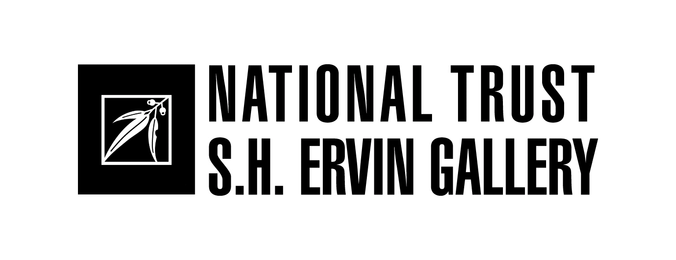
Private collection

Watson Road, Observatory Hill, The Rocks, Sydney
Gallery Front Desk: (02) 9258 0173
Gallery Hours: Tuesday – Sunday 11am-5pm www.shervingallery.com.auSunday afternoons @ the Gallery – Special guest talks selected Sundays at 3pm
Admission: $7 General, $4 National Trust Members/ Children under 12 free
GENESIS OF A PAINTER: GUY WARREN AT 95
15 April – 29 May 2016

At the grand age of 95, artist Guy Warren is celebrating with a special focus exhibition at the S.H. Ervin Gallery – Genesis of a painter: Guy Warren at 95

Guy Warren was born in Goulburn on 16 April 1921. As a child the family moved to Sydney and Guy grew up in the eastern suburbs & northern beaches. He left school at 14 to pursue his love of art and worked in Sydney at The Bulletin magazine and started formal art training part time at the J.S. Watkins Art School.

His epiphany came after volunteering for the AIF in 1941. He trained in the rainforest of Queensland, fell in love with it and then became overwhelmed by the mysterious beauty of Bougainville where the indigenous people decorated their bodies so that they could disappear and reappear at will. This became the liet-motif of his vision and the essential metaphor for him of the quintessential secret of painting: a notion of nature's camouflage within which questions of our existence may be hidden and found.

Warren studied at the National Art School as a rehabilitating soldier, and in 1950 married an English girl Joy and went to live in England where they stayed for eight years. Joy became a distinguished academic and ceramicist working until her death in 2011. Guy became a close friend of the distinguished art scholar and critic Norbert Lynton who later wrote a long introduction to his monograph - In search of Gaia (2003). But the most intriguing British encounter was with the young David Attenborough.

After seeing a BBC TV production depicting decorated native dancers of the New Guinea Highlands Guy wrote to the BBC requesting some still images and was put in touch with Attenborough who loaned many photos in exchange for a painting. After return to Australia in 1959 Guy pursued, along with his painting, a successful career as editor, writer and teacher. He was, and still is, exceptionally articulate as a speaker and writer, and warmly magnanimous, one could even say sage-like, in his appreciation of fellow artists.

The exhibition, curated by Barry Pearce, Emeritus Curator of Australian Art, AGNSW, was inspired from a visit to the artist's studio as Warren reflected on his growing sense of mortality and was considering how to disperse his work. Discovered in a stack of paintings in the corner were paintings of the 1950s from his London years and 1960s soon after his return to Sydney. The evident qualities of these works and the obsession with emergence and submergence of the figure in relation to its background, has resonated throughout his oeuvre to the present day.

This special focus exhibition features work from his earliest days in London during the 1950s and after his return to Sydney in 1958, together with recent works which show the enduring imagery of the relationship between the figure and background that signifies not only a timeless aspect of the language of painting but also the mystical connection between man and the environment.

The S.H. Ervin Gallery acknowledges the generous support of the Gordon Darling Foundation in the production of the catalogue
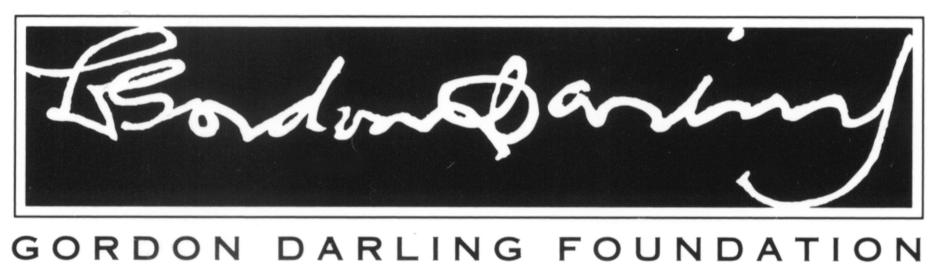
The S.H. Ervin Gallery is supported by

Guy Warren is represented by Olsen Irwin Gallery, Sydney

LIST OF WORKS

Jungle swamp, New Guinea 1944
pen and ink on paper 29.7 x 24.9cm
Australian War Memorial, Canberra ART94339

Soldier playing 1945
watercolour 22 x 32 cm
Private Collection

View of Mount Bagana, Bougainville 1945
watercolour 22 x 32 cm
Private Collection

Crashed plane, Bougainville 1945
watercolour 22 x 32 cm
Private Collection

“Mac” 1945
pencil on paper 33.2 x 25.4cm
Australian War Memorial, Canberra ART94340

Mount Bagana, Bougainville 1945
pencil on paper 25.2 x 34.8cm
Australian War Memorial, Canberra ART94338

Isamu Sato 1945
pencil on paper 33 x 27cm
Australian War Memorial, Canberra ART94343

Japanese POW, Bougainville 1945
pencil on paper 44 x 25.8cm
Australian War Memorial ART94344

Dropping supplies by air, Bougainville 1946
pencil on paper 26.2 x 33.5
Australian War Memorial ART94348

Destroyed landing barge, Bougainville 1946
watercolour 22 x 32 cm
Private Collection
Self portrait in jungle greens 1946
oil on canvas 61.5 x 40.5 cm
Private Collection

Soldiers bathing in a river 1954
oil on board 82 x 122 cm
Private Collection

Sketch after PNG photograph by David Attenborough c1954
watercolour
Private Collection

Bather, woman and volcano 1955
oil on board 122 x 102 cm
Private Collection

Mother and child 1955
oil on canvas 101.5 x 122 cm
Private Collection

Bathers (2) 1957
oil on canvas 100 x 128 cm
Private Collection

Green warrior 1957-58
oil on canvas 101 x 61 cm
Private Collection

Bathers in a red jungle (3) 1958
oil on linen 76 x 101 cm
Private Collection

Warrior and nude 1958
oil on linen 91 x 71 cm
Private Collection

Princess 1958
oil on canvas 76 x 101.5 cm
Private Collection

Torokina 1958
oil on canvas 102 x 127 cm
Private Collection

Red warrior 1959
oil on linen 127 x 76 cm
Private Collection

Rainforest, Torokina1959
oil on linen 102 x 127 cm
Private Collection

Horizontal image III 1960
oil on board 81.2 x 162.5 cm
Collection: Art Gallery of New South Wales - Purchased 1960

Return to the rainforest 1962
oil on board 122 x 183 cm
Private Collection

Prisoner of the sun1962
oil on canvas 51 x 61cm
Private Collection

Tiger in my garden 1963
oil on board 122 x 183 cm
Private Collection

Estuary in winter, Shoalhaven 1963
oil on board 94.1 x 127.4 cm
Collection: Art Gallery of New South Wales - Purchased 1964

Untitled 1963
oil on board 140 x 92 cm
Private Collection

Mungo brush 1963
pen, brush and ink on paper
Collection: Art Gallery of New South Wales - Purchased 1964

Green and gold 1964
acrylic on board 137 x 122 cm
Private Collection

Moon at Mungo Brush 1965
oil on canvas 100 x 126 cm
Mosman Art Collection

Above and below 1965
oil on board 122 x 102 cm
Private Collection

January Mungo Brush 1965
oil on canvas 102 x 61 cm
Private Collection

Coming storm, Mungo Brush 1965
watercolour 39 x 56 cm
Private Collection

Mungo Brush scrub 1965
watercolour 57 x 78 cm
Private Collection

Mungo Brush no 18 1965
watercolour 56 x 76 cm
Collection: Art Gallery of New South Wales - Purchased 1965

The clearing, Mungo Brush 1965
watercolour 57 x 78 cm
Private Collection

Mist, Mungo Brush 1 1966
watercolour 39 x 56 cm
Private Collection

Intimations of mortality: memories of Mort Bay 1982
ink on paper laid on canvas 154 x 457 cm
Private Collection

New York woman 1983
acrylic on paper 223 x 150.5 cm
Private Collection

