NEIL EVANS Bechino $580
varnished acrylic on paper flyer 10 x 10cm
FRED FOWLER Native and invasive species of Australia $11,750
mixed media and oil on canvas 213 x 178cm

JULIE HARRIS Jenolan $9,500
ink on paper 155 x112cm

CRAIG HANDLEY Luna #2 St. Kilda (self from another time) $17,000
oil on canvas 183 x 153cm
ROSS LAURIE Trees and light – Hurricane Gully $18,000
oil on canvas 137 x 182cm

NOEL McKENNA Sydney, my home 1979 – 2015 NFS
acrylic on canvas

BEN MILNE The Hill, Sofala $4,750
acrylic, dirt, and ash 122 x 116cm
JOHN MORRIS The heavens touch $12,000
oil on canvas 167 x 155cm
EVAN SALMON Steelworks (overcast) $3,500
oil on linen on board 36 x 86.5cm
PETER SHARP Rustle $12,000
oil and acrylic on linen 152 x 130cm

SHANNON SMILEY Backway, Heidelberg $16,800
oil on canvas 148 x 196cm

PETER STEVENS South Coast $10,500
oil on board 120 x 160cm

STEPHEN TREBILCOCK Red Kangaroo Paw $10,000
oil on canvas 120 x 150cm

PAUL TREFRY Homeless still human $33,000
silicone, fiberglass, horse hair, and polyester resin

EMMA WALKER Estuary $11,000
oil and mixed media on board 150 x 180cm

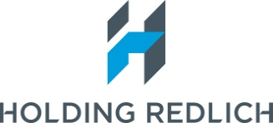
The Holding Redlich People’s Choice Award of $2,000 is presented to the artist
who attracts the most votes from viewers of the exhibition. Announced 11 September

THANK YOU
The 2015 Salon des Refusés exhibition is held with the generous assistance of the Art Gallery of New South Wales. Special thanks to Charlotte Cox & Steve Peters & the hard-working crew from the packing room.
Thank you to all the artists & their representative galleries participating in exhibition.

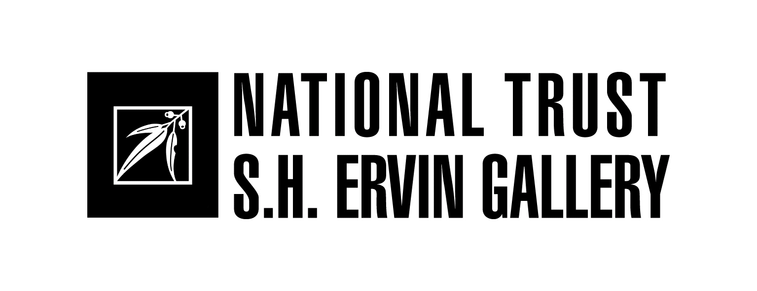
SALON DES REFUSÉS 2015
The alternative Archibald and Wynne Prize Selection
18 July – 13 September

The Salon des Refusés was initiated by the S.H. Ervin Gallery in 1992 in response to the large number of works entered into the Archibald Prize which were not selected for display in the official exhibition. The Archibald Prize is one of Australia’s most high profile and respected awards which attracts hundreds of entries each year and the S.H. Ervin Gallery’s ‘alternative’ selection has become a much anticipated feature of the Sydney art scene.

Each year our panel is invited to go behind the scenes of the judging process for the annual Archibald Prize for portraiture and Wynne Prize for landscape painting and figure sculpture at the Art Gallery of New South Wales, to select an exhibition from the many hundreds of works entered in both prizes but not chosen for the official award exhibition. The criteria for works selected in the Salon are quality, diversity, humour and innovation. Our panel viewed 832 Archibald Prize and 653 Wynne Prize entries at the Art Gallery of New South Wales to select the 53 works for this alternative exhibition.

The 2015 selection panel:

Damien Minton gallery manager, Watters Gallery
Jane Watters director, S.H. Ervin Gallery

The Salon des Refusés exhibition at the S.H. Ervin Gallery has established an excellent reputation that rivals the selections of the ‘official’ exhibition with works selected for quality, diversity, humour and experimentation which examine contemporary art practices, different approaches to portraiture and responses to the landscape.

HISTORY
The term Salon des Refusés comes from a group of French artists of the 1860s who held several breakaway exhibitions from the traditional Salon overseen by the Academy. In 1863, the French Academy rejected a staggering 2800 canvases submitted for the annual Salon exhibition. Among those refused were Paul Cézanne, Camille Pissarro, Henri Fantin-Latour, James Whistler and Édouard Manet, who entered his now legendary painting, Le déjeuner sur l'Herbe. This particular work was regarded as a scandalous affront to taste. The jury also argued these artists were “a clear danger to society and that the slightest encouragement would be risky.”

Since there were very few independent art exhibitions in imperial France, the taste of the buying public was dictated almost entirely by the Academy. Most members of the public invested only in artists sanctioned by the Salon. Rejection by the Academy therefore threatened many artists with professional extinction.

The protests that followed the Academy's 1863 decision were so public and so pointed that eventually Napoleon III himself appeared at the Palais de l'Industrie and demanded to see the rejected works. He then instructed the Academy to reconsider its selection and when it refused, the Emperor decreed that the rejected paintings go on display in a separate exhibition. And so the phrase Salon des Refusés entered into the world's artistic lexicon.

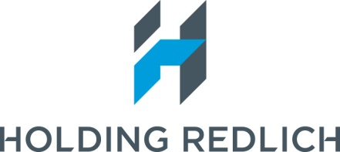
Principal Sponsor

Watson Road, Observatory Hill, The Rocks, Sydney
Tuesday - Sunday 11am – 5pm (Closed Mondays, Good Friday, Easter Monday & Anzac Day)
Admission: $7 Full, $4 National Trust members $5 Concessions children under 12 free
Tel: (02) 9258 0173

Public Program of artist talks Sunday afternoons @ 3pm Visit us for updates at www.shervingallery.com.au
Gallery floor talks every Tuesday @ 12noon
Group Bookings : 9258 0140

ARCHIBALD PRIZE SELECTIONS

ROGER BERRY Head. Cold. Portrait. (Roger Berry, artist) $200
oil on cough lozenge wrapper 5.5 x 4cm

PAUL BORG Gordon Morrison and the Dusty Miller (Gordon Morrison, director, $15,000
Art Gallery of Ballarat) oil and calcite on linen 152 x 71cm

SADIE CHANDLER Countess Elvis Richardson (Elvis Richardson, artist) $6,000
oil on canvas 150 x 100cm

JUN CHEN Armando Percuoco (Armando Percuoco, chef) NFS
oil on canvas 185.5 x 135cm

MARTIN EDGE Martin (Martin Edge, artist) $500
acrylic on canvas 40.3 x 40.3cm

JOHN EDWARDS Self portrait with Elsie (Jon Edwards, artist) SOLD
oil on canvas 223 x 167cm
MELISSA EGAN Self portrait, artist and muse $26,000
(Melissa Egan and Edmund Theermine, artist) oil on linen 160 x 140cm
NICOLETTE EISDELL Judy Cassab (Judy Cassab, artist) $3,000
oil on board 17.7 x 24cm
NEIL EVANS Anxiety blues (Neil Evans, artist) NFS
varnished acrylic on balsa wood 20 x 10cm
HÉLÈNE GROVE Headpiece self portrait (Self portrait, artist) $1, 000
acrylic on linen 77 x 102cm
MAUREEN HANSEN Robert writes memoirs: Portrait of Robert Forster $16,000 (Robert Forster, musician and writer) oil on linen 180 x 120cm
BENJAMIN JOHANSEN Monday morning (Jackie French, author) $9,900
acrylic on canvas 230 x 146cm
DAPENG LIU Carlotta – the Queen of the Cross (Carol Spencer, entertainer) $9,800 oil on linen 120 x 220cm
ALASDAIR MACINTYRE Self portrait in the studio (Alasdair Macintyre, artist) $3,300
acrylic on canvas 21.5 x 21.5cm
ROBERT MALHERBE Head of Zok (Zok Nystse, writer) NFS
oil on linen 24 x 18cm
PAUL MALLAM Ivana (Ivana Jirasek, curator) $7,500 oil on canvas 150 x 115cm
DEAN MANNING Dr. Kyrimis (Dr. Stavros Kyrimis, Consulate-General of Greece) $1,500
oil on wood 80 x 60cm
RACHEL MILNE Joe (Joe Eisenberg, retiring Director of Maitland Regional Art Gallery) NFS
oil on board 150 x 100cm

MICHAEL MUCCI From little things (Costa Georgiadis, Gardening Australia presenter and $15,000 environmentalist) tannin, acrylic, gouache and ink on watercolour paper 122 x 91cm

PAUL PROCEE Professor Allan Snyder (Allan Snyder, scientist) $7, 500
oil on copper 80 x 90cm

CHRISTOPHER PYETT Rosie Batty. Australian of the year 2015 NFS
(Rosie Batty, family violence advocate) watercolour 108.5 x 135cm

EVAN SALMON Self portrait (Evan Salmon, artist) $1,500
oil on marine ply 26.5 x 20cm
NIGEL SENSE Hi, I’m Jeremy Oxley $2,800
(Jeremy Oxley, lead singer of The Sunnyboys) acrylic on canvas 121 x 121cm

WENDY SHARPE Self portrait with puppet (Wendy Sharpe, artist) $24,000
oil on linen 160 x 163cm

IAN SMITH Quentin Dempster AM – After ABC (Quentin Dempster, journalist, $16,500
author, broadcaster) acrylic on canvas 180 x 120cm

TAI SNAITH Cup so full, portrait of Minna Gilligan (Minna Gilligan, artist) $4,000
mixed medium on canvas 153 x 102.5cm

NICK STATHOPOULOS Jenny Sages (Jenny Sages, artist) $25,000
acrylic and oil on canvas 137 x 137cm
DERRYN TAL CM in NY (Catherine Martin, costume, set, production designer $3,200 and film producer) mixed media 20 x 30cm

JAMES TINSLEY Robert Shenton French AC – Chief Justice of the High Court of SOLD
Australia (Robert Shenton French AC, Chief Justice)
oil and enamel on canvas 30.5 x 25cm
PETER WEGNER Andrew Sayers in cold studio (Andrew Sayers, artist, writer $4,000 and curator) oil and wax on board 31 x 31cm
HADYN WILSON Self portrait with scarf (V-2) (Hadyn Wilson, artist) NFS
oil on canvas 74 x 64cm
GUY JAMES WHITWORTH Respect your queer elders (William Yang and Michelle Francis $1,800 Collocott, artists) acrylic on canvas 100 x 80cm
JOHN WILLIAMS Austin and friend (Austin Cutter, student) NFS
oil on canvas 91 x 122cm
LEE WISE Self portrait (light of life) (Lee Wise, artist) $10,000
oil on canvas 170 x 120cm

WYNNE PRIZE SELECTIONS

DAVID ASHER BROOK Topography (V) $9,000
acrylic and enamel on linen 155 x 140cm
TIM BURNS Written on the water SOLD
oil on linen 183 x 168cm

TOM CARMENT Redleaf pool $5,000
watercolour and pigment ink on paper (9 sheets) 65 x 86cm overall
DAVID COLLINS Wedderburn Summer SOLD
acrylic, gouache, watercolour and charcoal on paper 77 x 168cm

