ELISABETH CUMMINGS Sir John Gorge. Mornington $48,000
oil on canvas

JULIE DONNELLY The pinnacles $2,000
crystal vessel sculpture

ANN GROCOTT Memory hill SOLD
oil on canvas

CRAIG HANDLEY council cleanup #6 TBA
oil on canvas

STEPHEN HART A sculptor by himself $8,500
carved timber sculpture

JOANNA LOGUE Remembered landscape II $8,800
acrylic on fabriano paper

MARGARET LOY PULA Anatye – bush potato $11,500
acrylic on linen

CHRISTOPHER MCVINISH Closed until further notice $15,000
oil on linen

PENELOPE METCALF Red centre (plein air project) each $900
oil on timber, 9 panels each 25 x 30cm

THEO PAPATHOMAS Raw landscape $6,600
oil on canvas

AMANDA PENROSE HART Untitled the hill NFS
oil on board

PAUL RYAN Mountain north, mountain south $12,000
oil on linen

PETER SHARP Sticks and stone 2 $11,000
oil and acrylic on linen

PETER STEVENS Coast $8,900
oil on board

ADRIANE STRAMPP Grey garden $11, 000
oil on linen

ROBYN SWEANEY Kerbside appeal SOLD
acrylic on linen

LUCY VADER My bootless cries NFS
oil paint on canvas

CRAIG WADDELL The waterhole $14,500
oil on linen

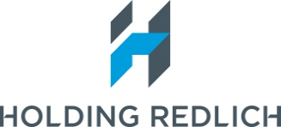
The Holding Redlich People’s Choice Award of $2,000 is presented to the artist
who attracts the most votes from viewers of the exhibition. Announced 12 September

THANK YOU
The 2014 Salon des Refusés exhibition is held with the generous assistance of the Art Gallery of New South Wales. Special thanks to Charlotte Cox & Steve Peters & the hard-working crew from the packing room.
Thank you to all the artists & their representative galleries participating in exhibition.

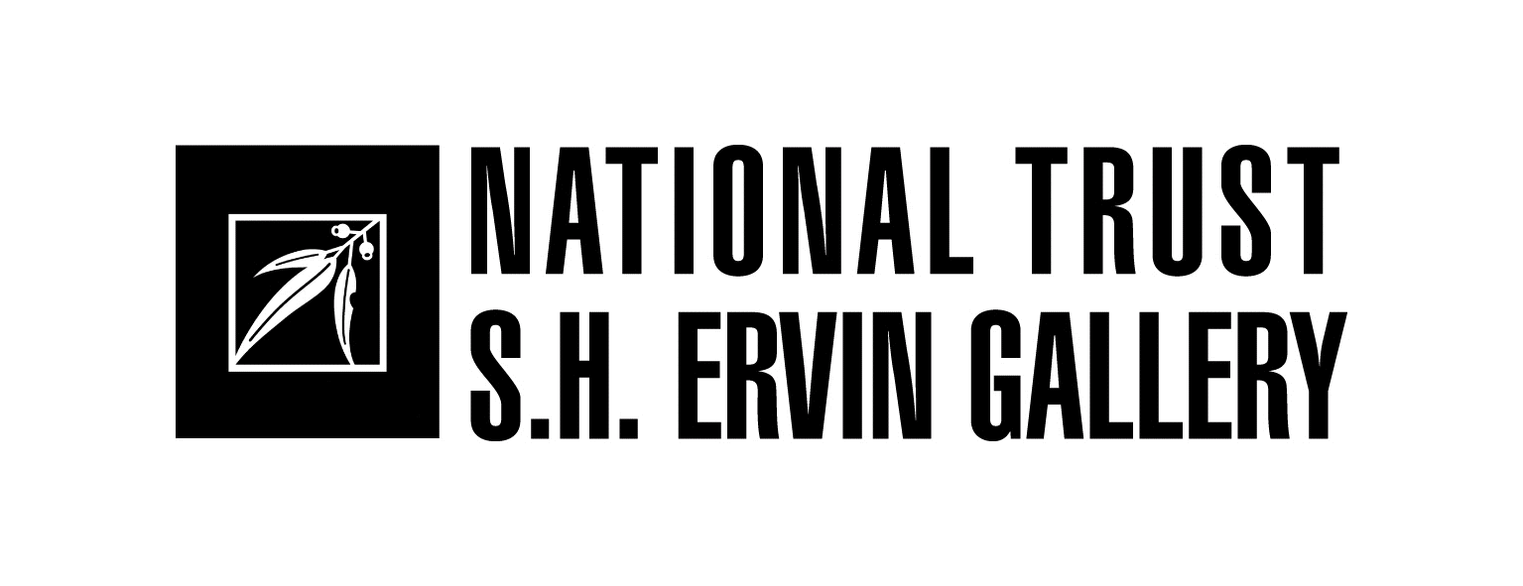
SALON DES REFUSÉS 2014
The alternative Archibald and Wynne Prize Selection
19 July – 14 September

The Salon des Refusés was initiated by the S.H. Ervin Gallery in 1992 in response to the large number of works entered into the Archibald Prize which were not selected for display in the official exhibition. The Archibald Prize is one of Australia’s most high profile and respected awards which attracts hundreds of entries each year and the S.H. Ervin Gallery’s ‘alternative’ selection has become a much anticipated feature of the Sydney art scene.

Each year our panel is invited to go behind the scenes of the judging process for the annual Archibald Prize for portraiture and Wynne Prize for landscape painting and figure sculpture at the Art Gallery of New South Wales, to select an exhibition from the many hundreds of works entered in both prizes but not chosen for the official award exhibition. The criteria for works selected in the Salon are quality, diversity, humour and innovation. Our panel viewed 884 Archibald Prize and 669 Wynne Prize entries at the Art Gallery of New South Wales to select the 56 works for this alternative exhibition.

The 2014 selection panel:

Gina Fairley arts writer, independent curator and director Slot
Andrew Frost art commentator, lecturer, curator and presenter of The Art Life
Jane Watters director, S.H. Ervin Gallery

The Salon des Refusés exhibition at the S.H. Ervin Gallery has established an excellent reputation that rivals the selections of the ‘official’ exhibition with works selected for quality, diversity, humour and experimentation which examine contemporary art practices, different approaches to portraiture and responses to the landscape.

HISTORY
The term Salon des Refusés comes from a group of French artists of the 1860s who held several breakaway exhibitions from the traditional Salon overseen by the Academy. In 1863, the French Academy rejected a staggering 2800 canvases submitted for the annual Salon exhibition. Among those refused were Paul Cézanne, Camille Pissarro, Henri Fantin-Latour, James Whistler and Édouard Manet, who entered his now legendary painting, Le déjeuner sur l'Herbe. This particular work was regarded as a scandalous affront to taste. The jury also argued these artists were “a clear danger to society and that the slightest encouragement would be risky.”

Since there were very few independent art exhibitions in imperial France, the taste of the buying public was dictated almost entirely by the Academy. Most members of the public invested only in artists sanctioned by the Salon. Rejection by the Academy therefore threatened many artists with professional extinction.

The protests that followed the Academy's 1863 decision were so public and so pointed that eventually Napoleon III himself appeared at the Palais de l'Industrie and demanded to see the rejected works. He then instructed the Academy to reconsider its selection and when it refused, the Emperor decreed that the rejected paintings go on display in a separate exhibition. And so the phrase Salon des Refusés entered into the world's artistic lexicon.

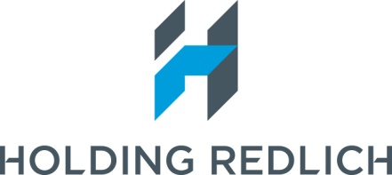
Principal Sponsor

Watson Road, Observatory Hill, The Rocks, Sydney
Tuesday - Sunday 11am – 5pm (Closed Mondays, Good Friday, Easter Monday & Anzac Day)
Admission: $7 Full, $4 National Trust members $5 Concessions children under 12 free
Tel: (02) 9258 0173

Public Program of artist talks Sunday afternoons @ 3pm Visit us for updates at www.shervingallery.com.au
Gallery floor talks every Tuesday @ 12noon
Group Bookings : 9258 0140

ARCHIBALD PRIZE SELECTIONS

CLARA ADOLPHS Alan Jones painting me NFS
(Alan Jones, artist) oil on canvas

ESMERALDA APONTE Songbird, Inga Liljestrom $8, 000
WOOD (Inga Liljestrom, singer-songwriter) gouache

DARYL AUSTIN Nijmegen 1936 SOLD
(Ingrid Kellenbach, CEO, Adelaide Central School of Art) oil on panel

MONIKA BEHRENS The two senses TBA
(Monika Behrens, artist) oil on polyester

TOM CARMENT Asma $3,600
(Asma Wang, community activist) oil on linen

CELESTE CHANDLER I feel for you 3 (Andrew) ` $9,000
(Andrew Dewhurst, artist) oil on canvas

TONY CURRAN Dr Doris McIlwain (Ouroboric #2) TBA
(Dr. Doris McIlwaine, Associate in Psychoanalysis &
Personality Psychology) oil on linen

ROBIN ELEY Veneration NFS
(Robin Eley, artist) oil on Belgian linen

JASMINE ESTORNINHO Ben Lewin, accessorized TBA
(Ben Lewin, director, screenwriter)

DAVID FAIRBAIRN Head of J.M. $14,000
(Jane McGowan, entrepreneur) mixed media

JUSTIN FEUERRING John Safran $10,000
(John Safran, writer) oil on canvas

PETER GARDINER Ron Ramsey (bonfire) $8,500
(Ron Ramsey, art administrator) oil on board

ROBERT HANNAFORD Phillip Adams NFS
(Phillip Adams, radio broadcaster, academic) oil on canvas

NICHOLAS HARDING Playing for Godot (Mullins, Weaving, Roxburgh and Quast) TBA
(Ensemble portrait of Luke Mullins, Hugo Weaving, Richard Roxburgh,
and Philip Quast, actors) oil on linen

RAYMOND KENYON Romaldo Giurgola: The architect in orthographic projection TBA
(Romaldo Giurgola AO, academic, architect, author)
watercolour

SAMANTHA KING Gotye TBA
(Wally de Backer, singer-songwriter) watercolour on Arches paper

JASPER KNIGHT Reko Rennie $18,000
(Reko Rennie, artist) enamel, masonite, Perspex and metal sign on board)

MICHAEL LINDEMAN Note to self (Andrew Denton) $9,000
(Andrew Denton, Australian television presenter)
acrylic on canvas over shaped board

DARREN McDONALD Brent and Andrew TBA
(Brent Harris and Andrew Browne, artists) oil on linen

JILL MCFARLANE Justine Clarke $5,500
(Justine Clarke, actor) oil on canvas

LEWIS MILLER A self portrait in three panels 2014 $7,700
(Lewis Miller, artist) oil on Belgian linen

JASON MOAD Self-Portrait with Mass Effect Hoodie TBA
(Jason Moad, artist) oil on linen

LINDA MORRIS General Michellen – Portrait of Michelle Chilton NFS
(Michelle Chilton, artist and designer) oil on canvas

STEPHEN NOTHLING Stephen Hart by himself $6,600
(Stephen Hart, artist) oil on canvas

LESLIE RICE Self portrait (painted by the artist at the halfway point of the term of NFS
his natural life) (Leslie Rice, artist) acrylic on velvet
JENNY SAGES Red Shoes - A portrait of Dr. Sarah Engledow TBA
(Dr Sarah Engledow, historian and curator) encaustic, oil,
and pigment on board

EVAN SALMON Self portrait 2014 $1,400
(Evan Salmon, artist) oil on cedar panel

RAELENE SHARP Russell Morris – At ease with the blues $20,000
(Russell Morris, singer-songwriter) oil on linen

BEN SMITH The Shift. Portrait of my wife. TBA
(Lisi Klein, artist) oil on board

NICK STATHOPOULOS Ugly – portrait of Robert Hoge NFS
(Robert Hoge, author) acrylic and oils on linen

MICHAEL VALE Mad World (a portrait of Mic Conway) $10,000
(Mic Conway, performer) oil on linen

BRONWEN Portrait of a sculptor as a sculpture $4,000
VAUGHAN-EVANS (Sam Jinks, artist) gesso and oil on board

PETER WEGNER Stella Young TBA
(Stella Young, disability activist) oil on panel

WYNNE PRIZE SELECTIONS

SCOTT BAKER Flood path NFS
Timber assemblage

CRAIG BARRETT Tahara – dry 2013 SOLD
oil on linen

MOSTYN BRAMLEY-MOORE Garden $9,750
oil on polyester canvas

PAMELA BRANAS City SOLD
oil on canvas

SOPHIE CAPE The earth whirls toward a creation unknown $24,800
oil, acrylic, blood, bone, charcoal, and soil on canvas

